**E-Commerce Product Delivery Prediction**

The aim of this project to predict whether the product from an e-commerce company will reach on time or not. This project also analyzes various factors that affect the delivery of the product as well as studies the customer behavior.

# Context

An international e-commerce company based wants to discover key insights from their customer database. They want to use some of the most advanced machine learning techniques to study their customers. The company sells electronic products.

# Data Dictionary

The dataset used for model building contained 10999 observations of 12 variables. The data contains the following information:

**Variable Description**

ID ID Number of Customers

|  |  |
| --- | --- |
| Warehouse_block | The Company have big Warehouse which is divided into block such as  A,B,C,D,E |
| Mode_of_Shipment | The Company Ships the products in multiple way such as Ship, Flight and Road |
| Customer_care_calls | The number of calls made from enquiry for enquiry of the shipment |
| Customer_rating | The company has rated from every customer. 1 is the lowest (Worst),  5 is the highest (Best) |
| Cost_of_the_Product | Cost of the Product in US Dollars |
| Prior_purchases | The Number of Prior Purchase |
| Product_importance | The company has categorized the product in the various parameter such as low, medium, high |
| Gender | Male and Female |
| Discount_offered | Discount offered on that specific product |
| Weight_in_gms | It is the weight in grams |
| Reached.on.Time_Y.N | It is the target variable, where 1 Indicates that the product has NOT reached on time and 0 indicates it has reached on time |

|  |
| --- |
| *#Importing the libraries* **import** numpy **as** np **import** pandas **as** pd **import** matplotlib.pyplot **as** plt **import** seaborn **as** sns |

In [ ]:

|  |  |  |
| --- | --- | --- |
| *#Loading the dataset*  df **=** pd**.**read_csv('E_Commerce.csv') df**.**head() |  |  |
| **ID Warehouse_block Mode_of_Shipment** | **Customer_care_calls** | **Customer_rating Cost** |

In [ ]:

Out[ ]:

**0** 1 D Flight 4 2

|  |  |  |  |  |  |  |  |
| --- | --- | --- | --- | --- | --- | --- | --- |
| **1** | 2 | F |  | Flight |  | 4 | 5 |
| **2** | 3 | A |  | Flight |  | 2 | 2 |
| **3** | 4 | B |  | Flight |  | 3 | 3 |
| **4** | 5 | C |  | Flight |  | 2 | 2 |

# Data Preprocessing 1

In [ ]: *#Checking the shape of the dataset* df**.**shape

|  |  |
| --- | --- |
| Out[ ]: | (10999, 12) |

In [ ]: *#Checking data types of the columns* df**.**dtypes

Out[ ]: ID int64 Warehouse_block object

Mode_of_Shipment object

Customer_care_calls int64

Customer_rating int64

Cost_of_the_Product int64

Prior_purchases int64

Product_importance object

Gender object

Discount_offered int64

Weight_in_gms int64 Reached.on.Time_Y.N int64 dtype: object

Dropping column ID because it is an index column

In [ ]: *#Drop column* df**.**drop(['ID'], axis**=**1, inplace**=True**)

In [ ]: *#Checking for null/missing values* df**.**isnull()**.**sum()

|  |  |
| --- | --- |
| Out[ ]: | Warehouse_block 0  Mode_of_Shipment 0  Customer_care_calls 0  Customer_rating 0  Cost_of_the_Product 0  Prior_purchases 0  Product_importance 0  Gender 0  Discount_offered 0  Weight_in_gms 0 Reached.on.Time_Y.N 0 dtype: int64 |

In [ ]: *#Checking for duplicate values* df**.**duplicated()**.**sum()

|  |  |
| --- | --- |
| Out[ ]: | 0  **Descriptive Statistics** |

In [ ]: df**.**describe()

Out[ ]: **Customer_care_calls Customer_rating Cost_of_the_Product Prior_purchases Disco**

**count** 10999.000000 10999.000000 10999.000000 10999.000000 1

|  |  |  |  |  |  |
| --- | --- | --- | --- | --- | --- |
| **mean** |  | 4.054459 | 2.990545 | 210.196836 | 3.567597 |
| **std** |  | 1.141490 | 1.413603 | 48.063272 | 1.522860 |
| **min** |  | 2.000000 | 1.000000 | 96.000000 | 2.000000 |
| **25%** |  | 3.000000 | 2.000000 | 169.000000 | 3.000000 |
| **50%** |  | 4.000000 | 3.000000 | 214.000000 | 3.000000 |
| **75%** |  | 5.000000 | 4.000000 | 251.000000 | 4.000000 |
| **max** |  | 7.000000 | 5.000000 | 310.000000 | 10.000000 |

|  |  |  |  |  |
| --- | --- | --- | --- | --- |
| df**.**head() |  |  |  |  |
| **Warehouse_block** | **Mode_of_Shipment** | **Customer_care_calls** | **Customer_rating** | **Cost_of_** |

In [ ]: Out[ ]:

**0** D Flight 4 2

|  |  |  |  |  |  |
| --- | --- | --- | --- | --- | --- |
| **1** | F | Flight |  | 4 | 5 |
| **2** | A | Flight |  | 2 | 2 |
| **3** | B | Flight |  | 3 | 3 |
| **4** | C | Flight |  | 2 | 2 |

# Exploratory Data Analysis

In the exploratory data analysis, I will be looking at the relationship between the target variable and the other variables. I will also be looking at the distribution of the variables across the dataset, in order to understand the data in a better way.

## Customer Gender Distribution

|  |
| --- |
| plt**.**pie(df['Gender']**.**value_counts(),labels **=** ['F','M'], autopct**=**'%1.1f%%', start plt**.**title('Gender Distribution') |

In [ ]:

Out[ ]: Text(0.5, 1.0, 'Gender Distribution')

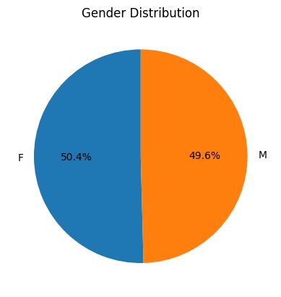

The dataset has the equal number of both males and female customers, with percentage of 49.6% and 50.4% respectively.

## Product Properties

|  |
| --- |
| fig, ax **=** plt**.**subplots(1,3,figsize**=**(15,5)) sns**.**histplot(df['Weight_in_gms'], ax**=**ax[0], kde**=True**)**.**set_title('Weight Distribu sns**.**countplot(x **=** 'Product_importance', data **=** df, ax**=**ax[1])**.**set_title('Product sns**.**histplot(df['Cost_of_the_Product'], ax**=**ax[2], kde**=True**)**.**set_title('Cost of t |

In [ ]:

Out[ ]: Text(0.5, 1.0, 'Cost of the Product')

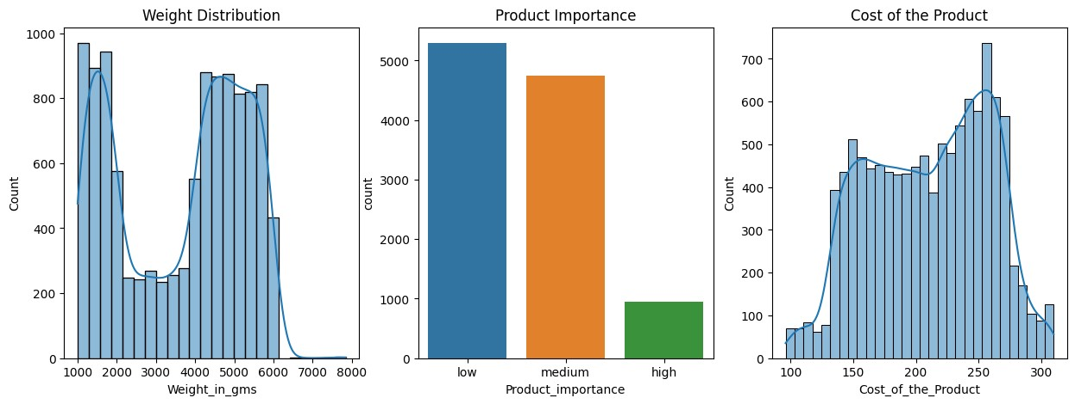

These three graphs explain the distribution of product properties - Weight, Cost and Importance in the dataset. Firstly, looking at the weight distribution, we can see that the products weighing between 1000-2000 grams and 4000-6000 grams are more in number. This means that the company is selling more of the products in these weight ranges. The second graph is about the product importance, where majority of the products have low or medium importance. The third graph is about the cost of the product. Third graph is about the cost distribution of the products, where there is increased distribution between 150-200 and 225-275 dollars.

From this, I conclude that majority of the products are lighter than 6000 grams, have low or medium importance and costs between 150-275 dollars.

## Logistics

In [ ]: fig, ax **=** plt**.**subplots(1,3,figsize**=**(15,5)) sns**.**countplot(x **=** 'Warehouse_block', data **=** df, ax**=**ax[0])**.**set_title('Warehouse B sns**.**countplot(x **=** 'Mode_of_Shipment', data **=** df, ax**=**ax[1])**.**set_title('Mode of Sh sns**.**countplot(x **=** 'Reached.on.Time_Y.N', data **=** df, ax**=**ax[2])**.**set_title('Reached

Out[ ]: Text(0.5, 1.0, 'Reached on Time')

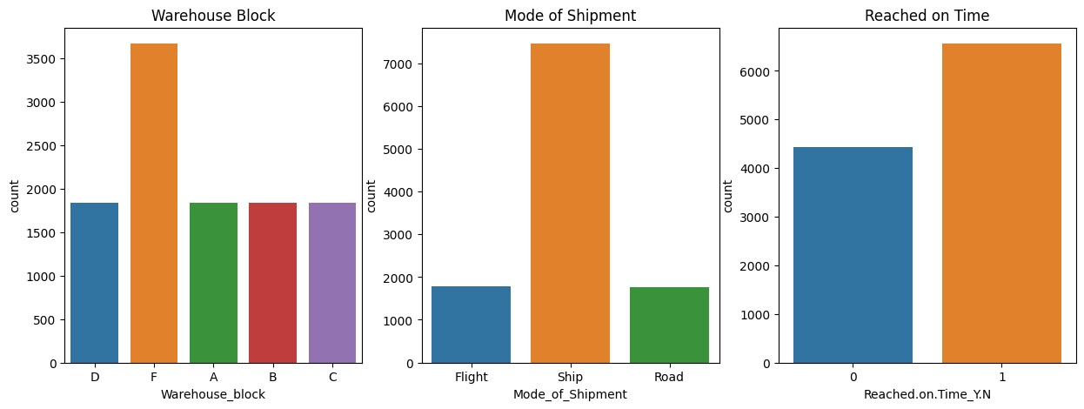

The above graphs visualizes the logistics and delivery of the product. In the first graph, we can see that the number of products from warehouse F is most i.e. 3500, whereas rest of the warehouses have nearly equal number of products. The second graph is about the shipment of the product, where majority of the products are shipped via Ship whereas nearly 2000 products are shipped by flight and road. Third graph is about the timely delivery of the product where we can see that the number of products delivered on time is more than the number of products not delivered on time.

From all the above graph, I assume that warehouse F is close to seaport, because warehouse F has the most number of products and most of the products are shipped via ship.

## Customer Experience

In [ ]: fig, ax **=** plt**.**subplots(2,2,figsize**=**(15,10)) sns**.**countplot(x **=** 'Customer_care_calls', data **=** df, ax**=**ax[0,0])**.**set_title('Custo sns**.**countplot(x **=** 'Customer_rating', data **=** df, ax**=**ax[0,1])**.**set_title('Customer sns**.**countplot(x **=** 'Prior_purchases', data **=** df, ax**=**ax[1,0])**.**set_title('Prior Pur sns**.**histplot(x **=** 'Discount_offered', data **=** df, ax**=**ax[1,1], kde **=** **True**)**.**set_titl

Out[ ]: Text(0.5, 1.0, 'Discount Offered')

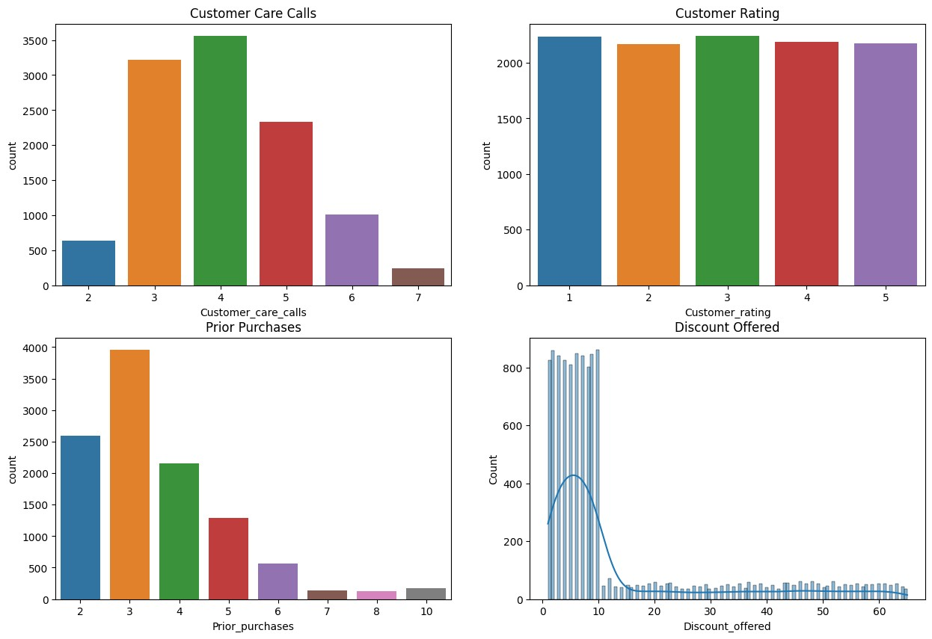

The above graphs visualizes the customer experience based on their customer care calls, rating, prior purchases and discount offered. The first graph shows the number of customer care calls done by the customers, where we can see that majority of the customers have done 3-4 calls, which could be a potential indicator, which shows that customers could be facing with the product delivery. In the second graph, we can see that the count of customer ratings across all ratings is same, but there are little more count in rating 1, which means customers are not satisfied with the service.

The third graph is about the prior purchases done by the customers, where we can see that majority of the customers have done 2-3 prior purchases, which means that customers who are having prior purchases, they are satisfied with the service, and they are buying more products. The fourth graph is about the discount offered on the products, where we can see that majority of the products have 0-10% discount, which means that the company is not offering much discount on the products.

## Customer Gender and Product Delivery

|  |
| --- |
| sns**.**countplot(x **=** 'Gender', data **=** df, hue **=** 'Reached.on.Time_Y.N')**.**set_title('G |

In [ ]:

Out[ ]: Text(0.5, 1.0, 'Gender vs Reached on Time')

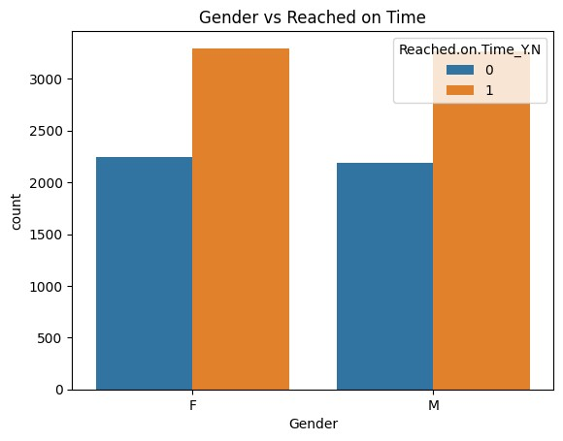

The number of products timely delivered for both the genders is same, which means there is no relation of customer gender and product delivery.

## Product Properties and Product Delivery

|  |
| --- |
| fig, ax **=** plt**.**subplots(1,3,figsize**=**(15,5)) sns**.**violinplot(y **=** df['Weight_in_gms'], ax**=**ax[0], kde**=True**, x **=** df['Reached.on.T sns**.**countplot(x **=** 'Product_importance', data **=** df, ax**=**ax[1], hue **=** 'Reached.on.T sns**.**violinplot(y **=** df['Cost_of_the_Product'], ax**=**ax[2], kde**=True**, x **=** df['Reache |

In [ ]:

Out[ ]: Text(0.5, 1.0, 'Cost of the Product')

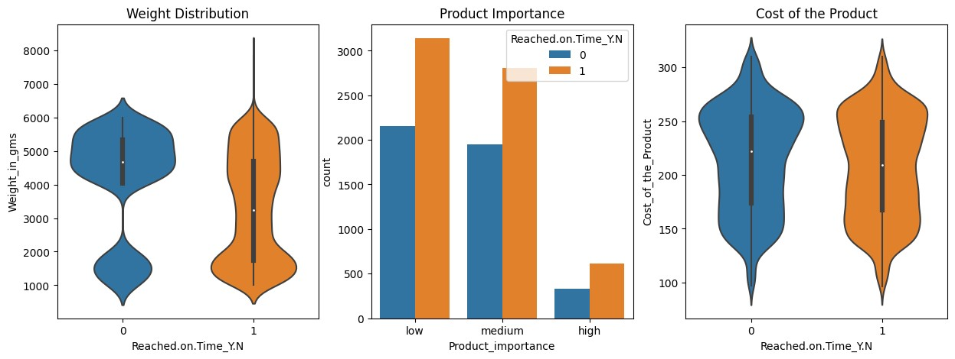

The above plots visualizes the relationship between product properties and product delivery. From the first graph, it is quite clear that product weight has an impact of timely delivery of the product. Products that weight more than 4500 grams are not delivered on time, in addition to that more products that weight between 2500 - 3500 grams are delivered timely. The second graph is about the product importance and product delivery, where we can see that there is no major difference between the product delivery based on the product importance. The third graph shows the relationship between the cost of the product and product delivery, where we can see that products that cost more than 250 have higher count of not delivered on time.

From this I conclude that product weight and cost has an impact on the product delivery.

## Logistics and Product Delivery

In [ ]: fig, ax **=** plt**.**subplots(1,2,figsize**=**(15,5)) sns**.**countplot(x **=** 'Warehouse_block', data **=** df, ax**=**ax[0], hue **=** 'Reached.on.Time sns**.**countplot(x **=** 'Mode_of_Shipment', data **=** df, ax**=**ax[1], hue **=** 'Reached.on.Tim

Out[ ]: Text(0.5, 1.0, 'Mode of Shipment')

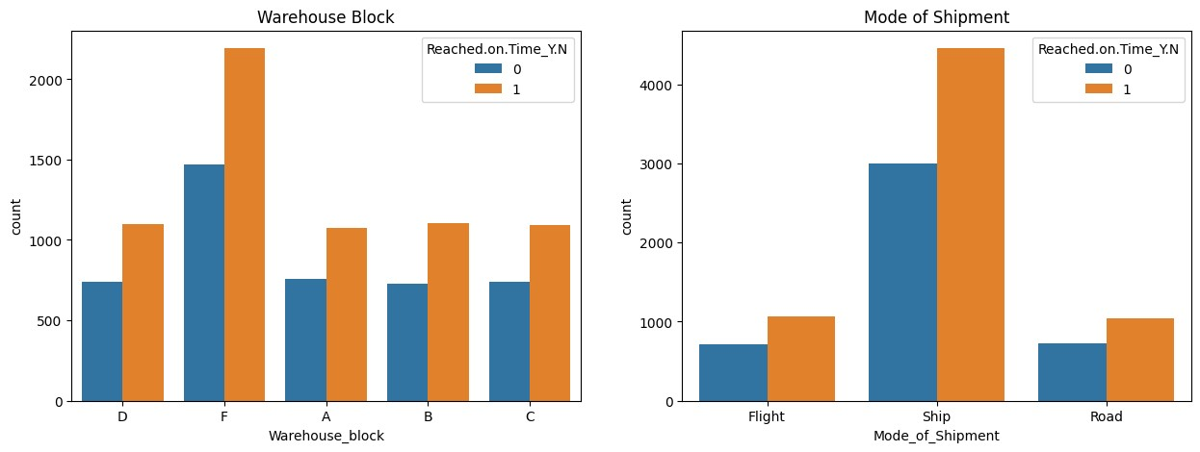

These graphs explain the relationship between the Logistic and timely delivery of the product. Since most of the products are shipped from warehouse F, I assumed that warehouse F is close to seaport, and most of the products are shipped via ship. In both the graphs, the difference between the number of products delivered on time and not delivered on time is constant across all the warehouse blocks and mode of shipment. This means that the logistic and mode of shipment has no impact on the product delivery.

## Customer Experience and Product Delivery

In [ ]:

|  |
| --- |
| fig, ax **=** plt**.**subplots(2,2,figsize**=**(15,10)) sns**.**countplot(x **=** 'Customer_care_calls', data **=** df, ax**=**ax[0,0],hue **=** 'Reached.on sns**.**countplot(x **=** 'Customer_rating', data **=** df, ax**=**ax[0,1],hue **=** 'Reached.on.Tim sns**.**countplot(x **=** 'Prior_purchases', data **=** df, ax**=**ax[1,0],hue **=** 'Reached.on.Tim sns**.**violinplot(x **=** 'Reached.on.Time_Y.N', y **=** 'Discount_offered' ,data **=** df, ax |

**=**

Out[ ]: Text(0.5, 1.0, 'Discount Offered')

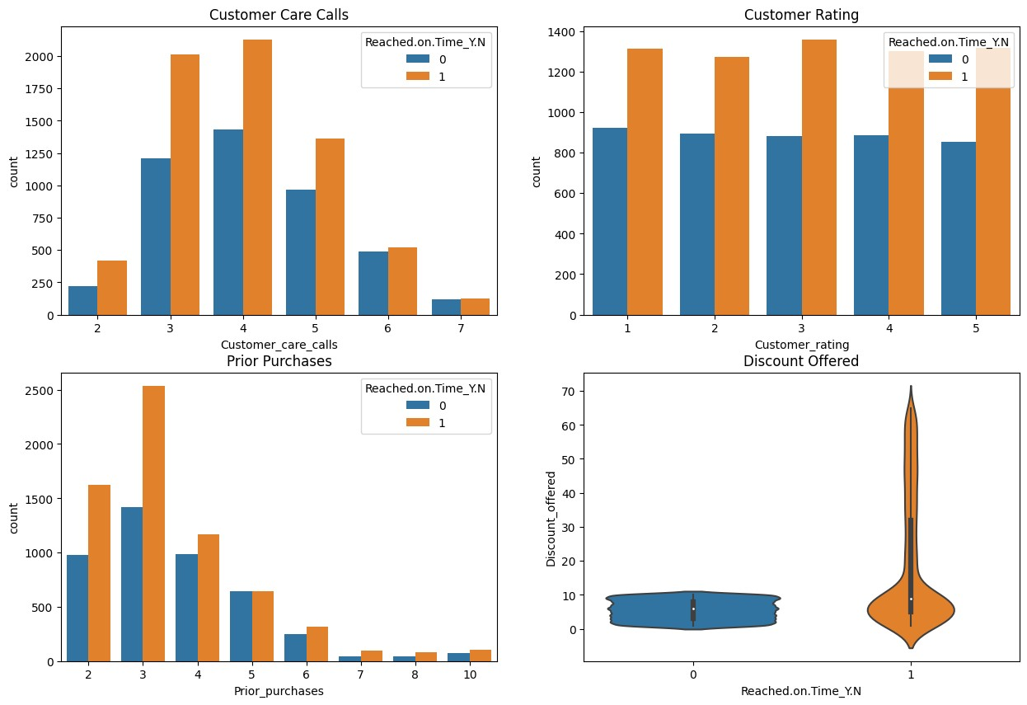

It is important to understand the customer experience and respond to services provided by the E-Commerce company. The above graphs explain the relationship between customer experience and product delivery. The first graph is about the customer care calls and product delivery, where we that the difference in timely and late delivery of the product decreases with increase in the number of calls by the customer, which means that with the delay in product delivery the customer gets anxious about the product and calls the customer care. The second graph is about the customer rating and product delivery, where we can see that customers who rating have higher count of products delivered on time.

The third graph is about the customer's prior purchase, which also shows that customers who have done more prior purchases have higher count of products delivered on time and this is the reason that they are purchasing again from the company. The fourth graph is about the discount offered on the product and product delivery, where we can see that products that have 0-10% discount have higher count of products delivered late, whereas products that have discount more than 10% have higher count of products delivered on time.

# Data Preprocessing 2

**Label Encoding the Categorical Variables**

|  |
| --- |
| **from** sklearn.preprocessing **import** LabelEncoder  *#Label encoding object* le **=** LabelEncoder()  *#columns for label encoding*  cols **=** ['Warehouse_block','Mode_of_Shipment','Product_importance', 'Gender']  *#label encoding* **for** i **in** cols: le**.**fit(df[i]) df[i] **=** le**.**transform(df[i]) print(i, df[i]**.**unique()) |

In [ ]:

Warehouse_block [3 4 0 1 2]

Mode_of_Shipment [0 2 1]

Product_importance [1 2 0]

Gender [0 1]

# Correlation Matrix Heatmap

|  |
| --- |
| plt**.**figure(figsize**=**(10,10))  sns**.**heatmap(df**.**corr(), annot**=True**, cmap**=**'coolwarm') |

In [ ]:

Out[ ]: <Axes: >

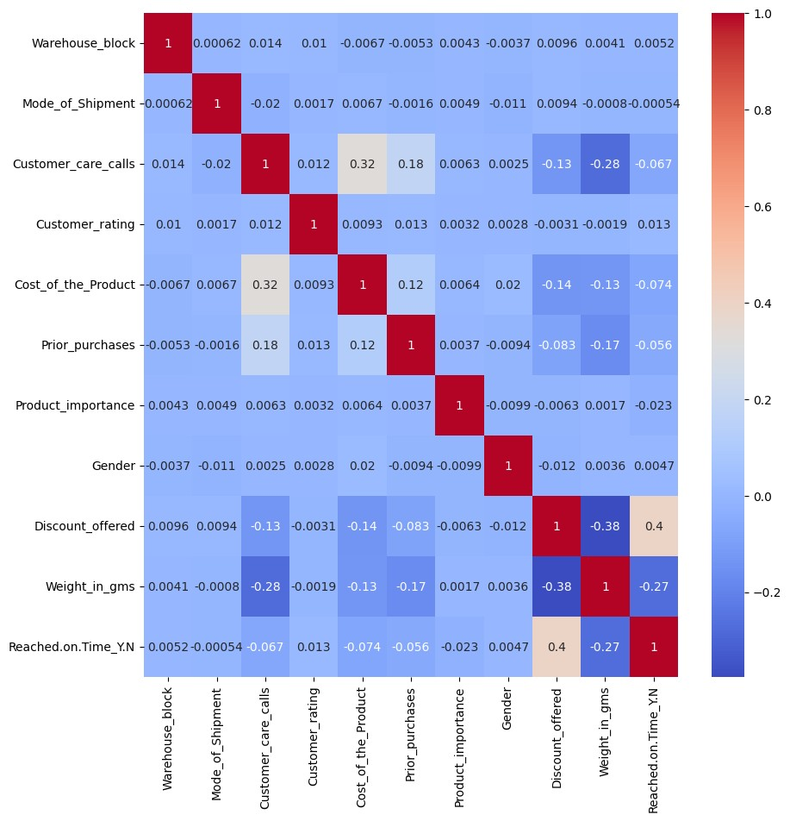

In the correlation matrix heatmap, we can see that there is positive correlation between cost of product and number of customer care calls.

|  |
| --- |
| sns**.**violinplot(x **=** 'Customer_care_calls', y **=** 'Cost_of_the_Product', data **=** df) |

In [ ]:

Out[ ]: <Axes: xlabel='Customer_care_calls', ylabel='Cost_of_the_Product'>

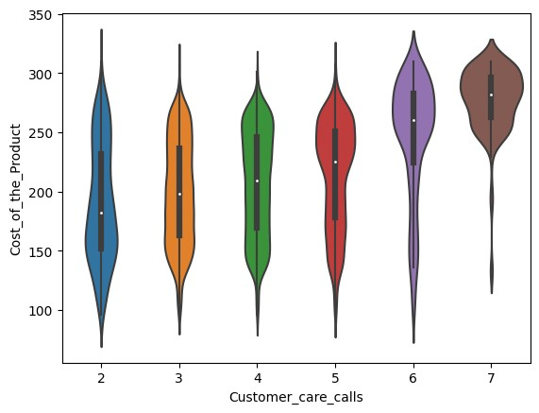

It is clear that customer are more concern regarding the delivery of the product when the cost of the product is high. This is the reason that they call the customer care to know the status of the product. So, it is important to make sure the delivery of the product is on time when the cost of the product is high.

# Train Test Split

|  |
| --- |
| **from** sklearn.model_selection **import** train_test_split  X_train, X_test, y_train, y_test **=** train_test_split(df**.**drop('Reached.on.Time_Y.N |

In [ ]:

# Model Building

I will be using the following models to predict the product delivery:

Random Forest Classifier

Decision Tree Classifier

Logistic Regression

K Nearest Neighbors

## Random Forest Classifier

|  |
| --- |
| **from** sklearn.ensemble **import** RandomForestClassifier  *#Random Forest Classifier Object* rfc **=** RandomForestClassifier() |

In [ ]:

|  |
| --- |
| *#Using GridSearchCV for hyperparameter tuning* **from** sklearn.model_selection **import** GridSearchCV  *#Parameter grid* param_grid **=** {  'max_depth': [4,8,12,16],  'min_samples_leaf': [2,4,6,8],  'min_samples_split': [2,4,6,8],  'criterion': ['gini', 'entropy'],  'random_state': [0,42]  }  *#GridSearchCV object*  grid **=** GridSearchCV(estimator**=**rfc, param_grid**=**param_grid, cv**=**5, n_jobs**=-**1, verbo  *#Fitting the model* grid**.**fit(X_train, y_train)  *#Best parameters*  print('Best parameters: ', grid**.**best_params_) |

In [ ]:

Fitting 5 folds for each of 256 candidates, totalling 1280 fits

Best parameters: {'criterion': 'gini', 'max_depth': 8, 'min_samples_leaf': 8, 'm in_samples_split': 2, 'random_state': 42}

|  |
| --- |
| *#Random Forest Classifier Object*  rfc **=** RandomForestClassifier(criterion**=**'gini', max_depth**=**8, min_samples_leaf**=**8,  *#Fitting the model* rfc**.**fit(X_train, y_train) |

In [ ]:

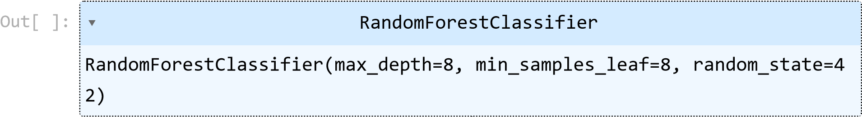

|  |
| --- |
| *#Training accuracy*  print('Training accuracy: ', rfc**.**score(X_train, y_train)) |

In [ ]:

|  |
| --- |
| *#predicting the test set results* rfc_pred **=** rfc**.**predict(X_test) |

Training accuracy: 0.7253096942834413 In [ ]:

## Decision Tree Classifier

|  |
| --- |
| **from** sklearn.tree **import** DecisionTreeClassifier  *#Decision Tree Classifier Object* dtc **=** DecisionTreeClassifier() |

In [ ]:

|  |
| --- |
| *#Using GridSearchCV for hyperparameter tuning* **from** sklearn.model_selection **import** GridSearchCV  *#Parameter grid* param_grid **=** {  'max_depth': [2,4,6,8],  'min_samples_leaf': [2,4,6,8],  'min_samples_split': [2,4,6,8], |

In [ ]:

|  |
| --- |
| 'criterion': ['gini', 'entropy'], 'random_state': [0,42]}  *#GridSearchCV object*  grid **=** GridSearchCV(estimator**=**dtc, param_grid**=**param_grid, cv**=**5, n_jobs**=-**1, verbo  *#Fitting the model* grid**.**fit(X_train, y_train)  *#Best parameters*  print('Best parameters: ', grid**.**best_params_) |

Fitting 5 folds for each of 256 candidates, totalling 1280 fits

Best parameters: {'criterion': 'gini', 'max_depth': 6, 'min_samples_leaf': 6, 'm in_samples_split': 2, 'random_state': 0}

|  |
| --- |
| *#Decision Tree Classifier Object*  dtc **=** DecisionTreeClassifier(criterion**=**'gini', max_depth**=**6, min_samples_leaf**=**6,  *#Fitting the model* dtc**.**fit(X_train, y_train) |

In [ ]:

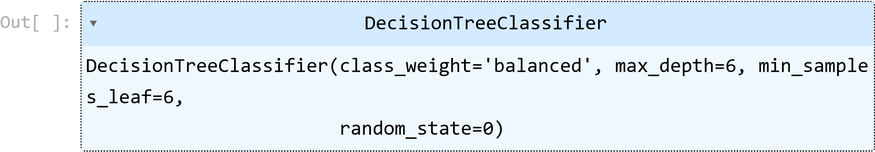

|  |
| --- |
| *#Training accuracy*  print('Training accuracy: ', dtc**.**score(X_train, y_train)) |

In [ ]:

Training accuracy: 0.6913285600636436

In [ ]: *#predicting the test set results* dtc_pred **=** dtc**.**predict(X_test)

## Logistic Regression

|  |
| --- |
| **from** sklearn.linear_model **import** LogisticRegression  *#Logistic Regression Object* lr **=** LogisticRegression() |

In [ ]:

In [ ]: *#fitting the model*

lr**.**fit(X_train, y_train)

Out[ ]: ▾LogisticRegression

LogisticRegression()

In [ ]: *#Training accuracy* lr**.**score(X_train, y_train)

|  |  |
| --- | --- |
| Out[ ]: | 0.6356404136833731 |

In [ ]: *#predicting the test set results*

lr_pred **=** lr**.**predict(X_test)

## K Nearest Neighbors

|  |
| --- |
| **from** sklearn.neighbors **import** KNeighborsClassifier  *#KNN Classifier Object* knn **=** KNeighborsClassifier() |

In [ ]:

In [ ]: *#fitting the model*

knn**.**fit(X_train, y_train)

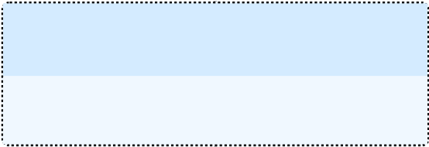Out[ ]: ▾KNeighborsClassifier

KNeighborsClassifier()

In [ ]: *#training accuracy* knn**.**score(X_train, y_train)

|  |  |
| --- | --- |
| Out[ ]: | 0.7782702579838618 |

In [ ]: *#predicting the test set results*

knn_pred **=** knn**.**predict(X_test)

# Model Evaluation

In [ ]: **from** sklearn.metrics **import** accuracy_score, confusion_matrix, classification_rep

In [ ]: fig, ax **=** plt**.**subplots(2,2,figsize**=**(15,10)) sns**.**heatmap(confusion_matrix(y_test, rfc_pred), annot**=True**, cmap**=**'coolwarm', ax**=** sns**.**heatmap(confusion_matrix(y_test, dtc_pred), annot**=True**, cmap**=**'coolwarm', ax**=** sns**.**heatmap(confusion_matrix(y_test, lr_pred), annot**=True**, cmap**=**'coolwarm', ax**=**a sns**.**heatmap(confusion_matrix(y_test, knn_pred), annot**=True**, cmap**=**'coolwarm', ax**=**

Out[ ]: Text(0.5, 1.0, 'KNN Classifier')

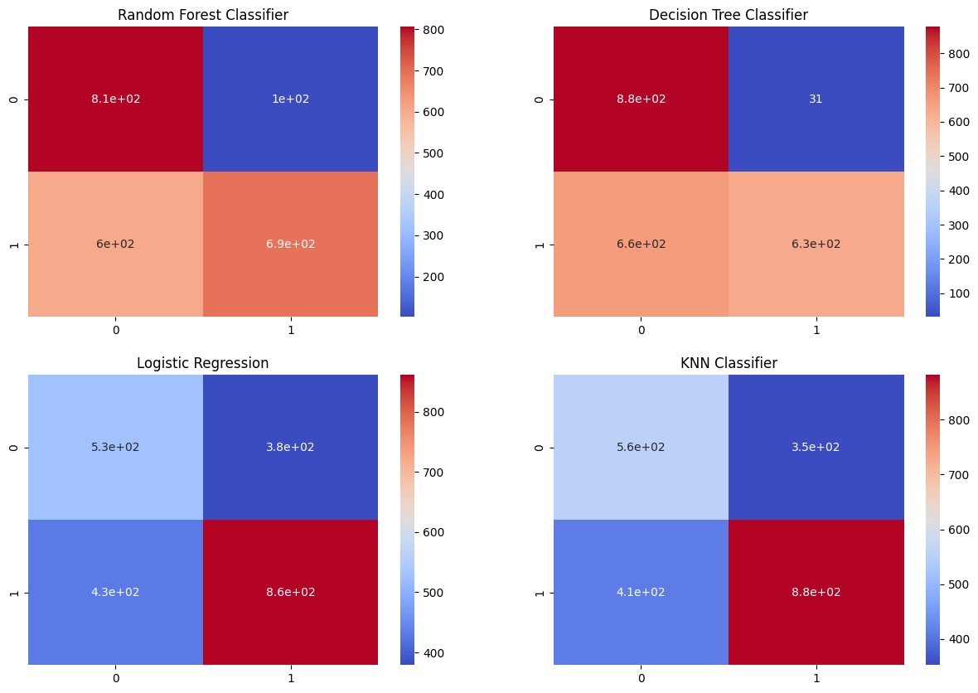

|  |
| --- |
| *#classification report*  print('Random Forest Classifier: \n', classification_report(y_test, rfc_pred)) print('Decision Tree Classifier: \n', classification_report(y_test, dtc_pred)) print('Logistic Regression: \n', classification_report(y_test, lr_pred)) print('KNN Classifier: \n', classification_report(y_test, knn_pred)) |

In [ ]:

Random Forest Classifier: precision recall f1-score support

0 0.57 0.89 0.70 908 1 0.87 0.54 0.66 1292

accuracy 0.68 2200 macro avg 0.72 0.71 0.68 2200 weighted avg 0.75 0.68 0.68 2200

Decision Tree Classifier: precision recall f1-score support

0 0.57 0.97 0.72 908 1 0.95 0.49 0.65 1292

accuracy 0.69 2200 macro avg 0.76 0.73 0.68 2200 weighted avg 0.80 0.69 0.68 2200

Logistic Regression: precision recall f1-score support

0 0.55 0.58 0.57 908 1 0.69 0.67 0.68 1292

accuracy 0.63 2200 macro avg 0.62 0.62 0.62 2200 weighted avg 0.64 0.63 0.63 2200

KNN Classifier: precision recall f1-score support

0 0.58 0.61 0.59 908 1 0.71 0.68 0.70 1292

accuracy 0.65 2200 macro avg 0.65 0.65 0.65 2200 weighted avg 0.66 0.65 0.66 2200

**Model Comparison**

In [ ]:

|  |
| --- |
| models **=** ['Random Forest Classifier', 'Decision Tree Classifier', 'Logistic Regr accuracy **=** [accuracy_score(y_test, rfc_pred), accuracy_score(y_test, dtc_pred), sns**.**barplot(x**=**models, y**=**accuracy, palette**=**'magma')**.**set_title('Model Comparison' plt**.**xticks(rotation**=**90) plt**.**ylabel('Accuracy') |

)

Out[ ]: Text(0, 0.5, 'Accuracy')

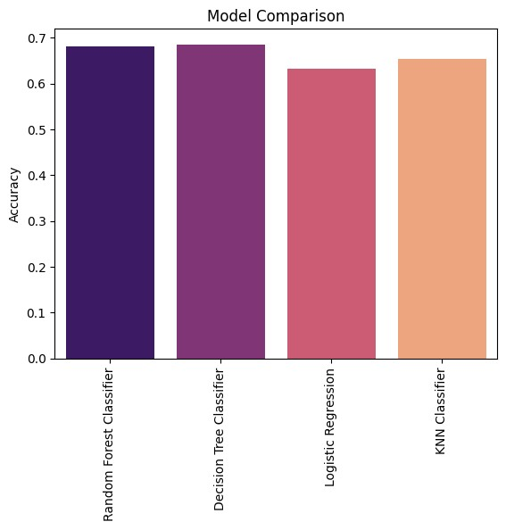

# Conclusion

The aim of the project was to predict whether the product from an e-commerce company will reach on time or not. This project also analyzes various factors that affect the delivery of the product as well as studies the customer behavior. From the exploratory data analysis, I found that the product weight and cost has an impact on the product delivery. Where product that weighs between 2500 - 3500 grams and having cost less than 250 dollars had higher rate of being delivered on time. Most of the products were shipped from warehouse F though ship, so it is quite possible that warehouse F is close to a seaport.

The customer's behaviour also help in predicting the timely delivery of the product. The more the customer calls, higher the chances the product delivery is delayed.

Interestingly, the customers who have done more prior purchases have higher count of products delivered on time and this is the reason that they are purchasing again from the company. The products that have 0-10% discount have higher count of products delivered late, whereas products that have discount more than 10% have higher count of products delivered on time.

Coming to the machine learning models, the decision tree classifier as the highest accuracy among the other models, with accuracy of 69%. The random forest classifier and logistic regression had accuracy of 68% and 67% respectively. The K Nearest Neighbors had the lowest accuracy of 65%.